**TUGAS 2**

NAMA : ESTY NAFILAH PUTRI

NIM : 200209502056

KELAS : PTIK C

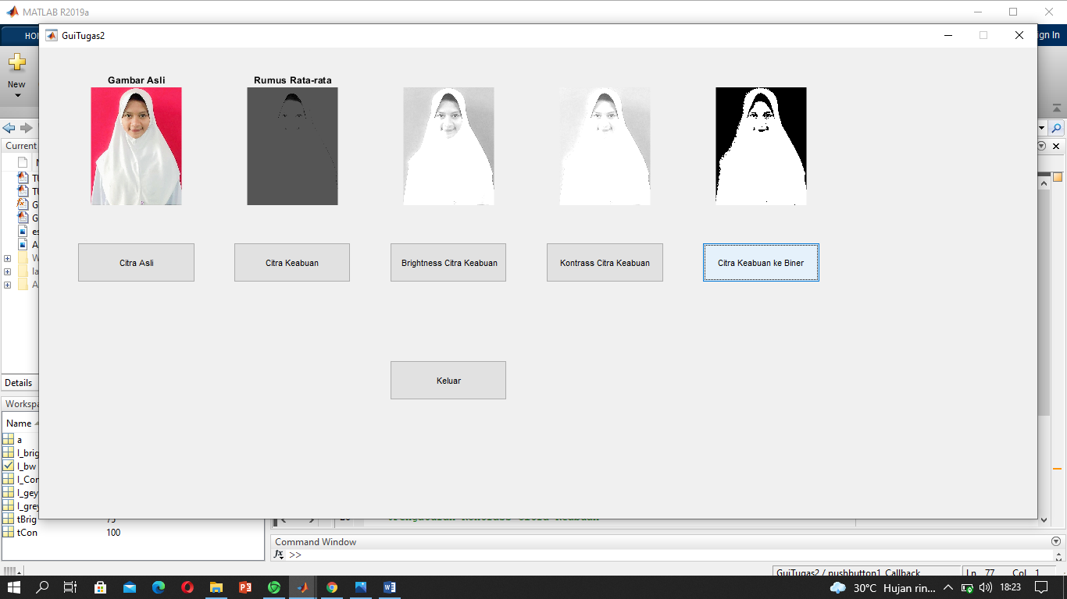

SYNTAX GUI

unction varargout = GuiTugas2(varargin)

% GUITUGAS2 MATLAB code for GuiTugas2.fig

% GUITUGAS2, by itself, creates a new GUITUGAS2 or raises the existing

% singleton*.

%

% H = GUITUGAS2 returns the handle to a new GUITUGAS2 or the handle to

% the existing singleton*.

%

% GUITUGAS2('CALLBACK',hObject,eventData,handles,...) calls the local

% function named CALLBACK in GUITUGAS2.M with the given input arguments.

%

% GUITUGAS2('Property','Value',...) creates a new GUITUGAS2 or raises the

% existing singleton*. Starting from the left, property value pairs are

% applied to the GUI before GuiTugas2_OpeningFcn gets called. An

% unrecognized property name or invalid value makes property application

% stop. All inputs are passed to GuiTugas2_OpeningFcn via varargin.

%

% *See GUI Options on GUIDE's Tools menu. Choose "GUI allows only one

% instance to run (singleton)".

%

% See also: GUIDE, GUIDATA, GUIHANDLES

% Edit the above text to modify the response to help GuiTugas2

% Last Modified by GUIDE v2.5 13-Oct-2021 18:22:44

% Begin initialization code - DO NOT EDIT

gui_Singleton = 1;

gui_State = struct('gui_Name', mfilename, ...

'gui_Singleton', gui_Singleton, ...

'gui_OpeningFcn', @GuiTugas2_OpeningFcn, ...

'gui_OutputFcn', @GuiTugas2_OutputFcn, ...

'gui_LayoutFcn', [] , ...

'gui_Callback', []);

if nargin && ischar(varargin{1})

gui_State.gui_Callback = str2func(varargin{1});

end

if nargout

[varargout{1:nargout}] = gui_mainfcn(gui_State, varargin{:});

else

gui_mainfcn(gui_State, varargin{:});

end

% End initialization code - DO NOT EDIT

% --- Executes just before GuiTugas2 is made visible.

function GuiTugas2_OpeningFcn(hObject, eventdata, handles, varargin)

% This function has no output args, see OutputFcn.

% hObject handle to figure

% eventdata reserved - to be defined in a future version of MATLAB

% handles structure with handles and user data (see GUIDATA)

% varargin command line arguments to GuiTugas2 (see VARARGIN)

% Choose default command line output for GuiTugas2

handles.output = hObject;

% Update handles structure

guidata(hObject, handles);

% UIWAIT makes GuiTugas2 wait for user response (see UIRESUME)

% uiwait(handles.figure1);

% --- Outputs from this function are returned to the command line.

function varargout = GuiTugas2_OutputFcn(hObject, eventdata, handles)

% varargout cell array for returning output args (see VARARGOUT);

% hObject handle to figure

% eventdata reserved - to be defined in a future version of MATLAB

% handles structure with handles and user data (see GUIDATA)

% Get default command line output from handles structure

varargout{1} = handles.output;

% --- Executes on button press in pushbutton1.

function pushbutton1_Callback(hObject, eventdata, handles)

% hObject handle to pushbutton1 (see GCBO)

% eventdata reserved - to be defined in a future version of MATLAB

% handles structure with handles and user data (see GUIDATA)

axes(handles.axes1)

a = imread('esty.jpg');

imshow(a)

title('Gambar Asli')

% --- Executes on button press in pushbutton2.

function pushbutton2_Callback(hObject, eventdata, handles)

% hObject handle to pushbutton2 (see GCBO)

% eventdata reserved - to be defined in a future version of MATLAB

% handles structure with handles and user data (see GUIDATA)

axes(handles.axes2)

a = imread('esty.jpg');

I_gey = (a(:,:,1)+a(:,:,2)+a(:,:,3))/3;

imshow(I_gey)

title('Rumus Rata-rata')

% --- Executes on button press in pushbutton3.

function pushbutton3_Callback(hObject, eventdata, handles)

% hObject handle to pushbutton3 (see GCBO)

% eventdata reserved - to be defined in a future version of MATLAB

% handles structure with handles and user data (see GUIDATA)

axes(handles.axes3)

a = imread('esty.jpg');

I_greyKom = 0.4*a(:,:,1)+0.32*a(:,:,2)+0.28*a(:,:,3);

tBrig = 75;

I_brig = I_greyKom + tBrig;

imshow(I_brig)

% --- Executes on button press in pushbutton4.

function pushbutton4_Callback(hObject, eventdata, handles)

% hObject handle to pushbutton4 (see GCBO)

% eventdata reserved - to be defined in a future version of MATLAB

% handles structure with handles and user data (see GUIDATA)

axes(handles.axes4)

a = imread('esty.jpg');

I_greyKom = 0.4*a(:,:,1)+0.32*a(:,:,2)+0.28*a(:,:,3);

tCon = 100;

I_Con = I_greyKom + tCon;

imshow(I_Con)

% --- Executes on button press in pushbutton5.

function pushbutton5_Callback(hObject, eventdata, handles)

% hObject handle to pushbutton5 (see GCBO)

% eventdata reserved - to be defined in a future version of MATLAB

% handles structure with handles and user data (see GUIDATA)

axes(handles.axes5)

a = imread('esty.jpg');

I_bw = im2bw(a,0.5);

imshow(I_bw)

% --- Executes on button press in pushbutton6.

function pushbutton6_Callback(hObject, eventdata, handles)

% hObject handle to pushbutton6 (see GCBO)

% eventdata reserved - to be defined in a future version of MATLAB

% handles structure with handles and user data (see GUIDATA)

delete (handles.figure1)